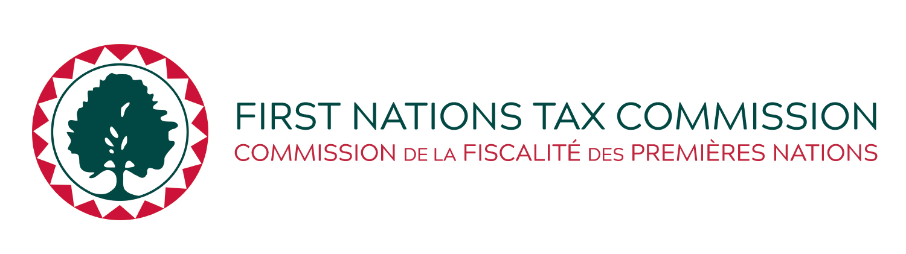

July 28, 2025

**Proposed Amendments to the Standards for First Nation Accommodation Operator Business Activity Tax Laws, 2017**

Standards established by the First Nations Tax Commission (FNTC) reflect best practices in property taxation, and are designed to support First Nation economic growth, First Nation jurisdiction, property tax harmonization, and the interests of all stakeholders in the First Nation property tax system.

Under the *First Nations Fiscal Management* Act (FMA or the “Act”), the FNTC reviews and approves laws. Section 35(1)(a) of the Act gives the FNTC the authority to establish standards, not inconsistent with the regulations, respecting the form and content of local revenue laws. The standards established by the FNTC are additional requirements and, together with the Act and its associated regulations, form the regulatory framework governing First Nation taxation under the Act. As a matter of policy, the FNTC seeks public input prior to introducing or significantly amending its standards. This input is critical in developing standards that are acceptable and effective for participating First Nations and their taxpayers.

In March 2017, the FNTC introduced *Standards for First Nation Accommodation Operator Business Activity Tax Laws, 2017*. These Standards govern laws established by First Nations concerning the business activity taxation of accommodation providers like hotels and motels operating on reserves. The Standards were further amended and consolidated in 2019.

In July 2025, the FNTC approved proposed changes to the Standards to bring about national consistency in the setting of initial tax rates of business activity taxation of accommodation operators and to increase the maximum tax rate to 6%.

The proposed changes to the Standards would:

* eliminate the requirement of initially following provincial tax rate maximums and,
* increasing the maximum tax rate from 5% to 6%

The FNTC is seeking public input in respect of these proposed amendments to the Standards. If you wish to learn more, please contact the FNTC at [mail@fntc.ca](mailto:mail@fntc.ca). Electronic versions of the proposed Standards are available at [www.fntc.ca](http://www.fntc.ca) or by clicking the link below:

[*Standards for First Nation Accommodation Operator Business Activity Tax Laws, 2017*](https://fntc.ca/wp-content/uploads/publicinput/2025/BAT-Accommodation-Operator-Standards-for-PIP-Tracked-Changes_2025-07-28-EN.pdf)

Please direct your written comments on or before August 29, 2025 to:

**First Nations Tax Commission**

321-345 Chief Alex Thomas Way

Kamloops BC  
V2H 1H1

Telephone: (250) 828-9857

Fax: (250) 828-9858

Email: mail@fntc.ca